Deonté Griffin-Quick 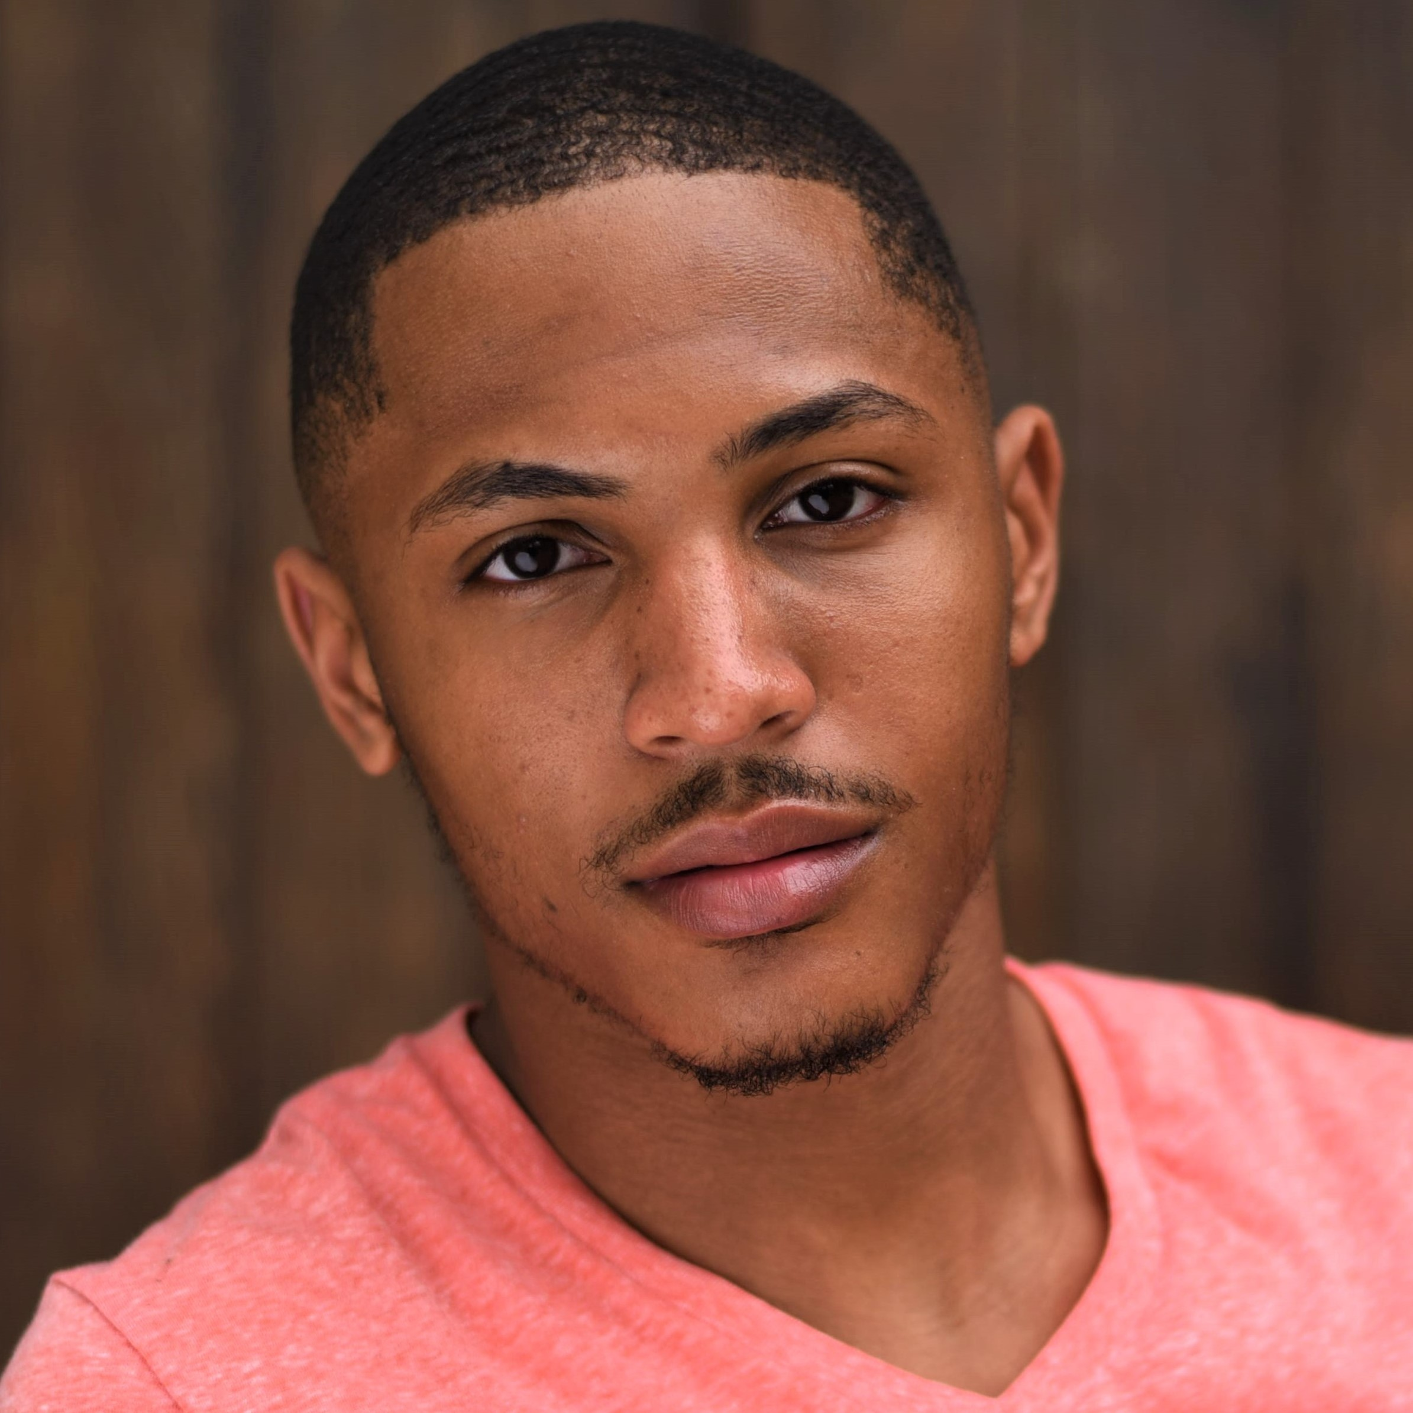
Equity Membership Candidate

Height: 5’9” Vocal Part: Tenor Hair: Brown
Weight: 140 lbs. (908) 943-1406 Eyes: Brown
deontegq@aol.com

Theatre

While You Were Preaching Matt Jr. dir. Michael Carr Apollo Theater, NYC
Iago Waiter dir. SuzAnne Barabas NJ Repertory Company
Ragtime Harlem Ensemble dir. Kate Swan 4th Wall Theatre, Inc.
Godspell Ensemble dir. Tori Clemens Triple Threat Productions
Class Action Ensemble dir. Laurie Mullen-Woods Triple Threat Productions
Seussical: The Musical Who/Ensemble dir. Holly Logue Kean University
Julius Caesar Publius dir. Ernest Wiggins Kean University
Midsummer Night’s Dream Theseus dir. Robin Horn Academy for Performing Arts
Anything Goes Sailor dir. Juan Pineda Academy for Performing Arts
Into the Woods Narrator dir. Valerie Pineda Academy for Performing Arts
Showcases

Another Hundred Stories The Applicant - Mr. Lamb APA Senior Showcase
Got Theatre? No Exit - Cradeau / Fences - Cory APA Junior Showcase
Choral Experiences

Kean University Gospel Choir Vice-President 2014 - Present
Awards: McDonald’s Gospelfest Competition Adult Choir Category 2016, 2017
Venues: New Jersey Performing Arts Center, Prudential Center, Fox 5 Good Day NY

Education/ Training

BA Theatre Performance Kean University Theatre Conservatory
Voice Martin Hurt
Dance Michele Mossay, Paul McRae, Michelle Perosi, Dawud Jackson
Stage Combat Tori Clemens

Special Skills
Licensed Minister, Singing (Gospel Background), Choral singing, Sight reading music, Recording studio experience, Physical movement, Rhythmically inclined, Ensemble collaboration, Basic dance (Ballet, Jazz, Modern, West African), Ironing, Basic Stage Hand and Sword Combat, Valid NJ Driver’s license, US Passport, CPR/First Aid Certified

